Test Case Document
Tools:
- pytest in Python to implement and run unit tests.
- Flask’s testing client, combined with pytest for integration tests.
- Scikit-learn's metrics module for measuring accuracy, precision, and recall.
- Scikit-learn for classification metrics; pytest for end-to-end testing scripts that simulate receiving and flagging an email.
Sprint 2 Testing Plan
In Sprint 1, setting up of foundational components, therefore testing will focus on:
- Test Case TC_001: Ensuring the local email server setup works.
- Test Case TC_002: Verifying the database and email generation.
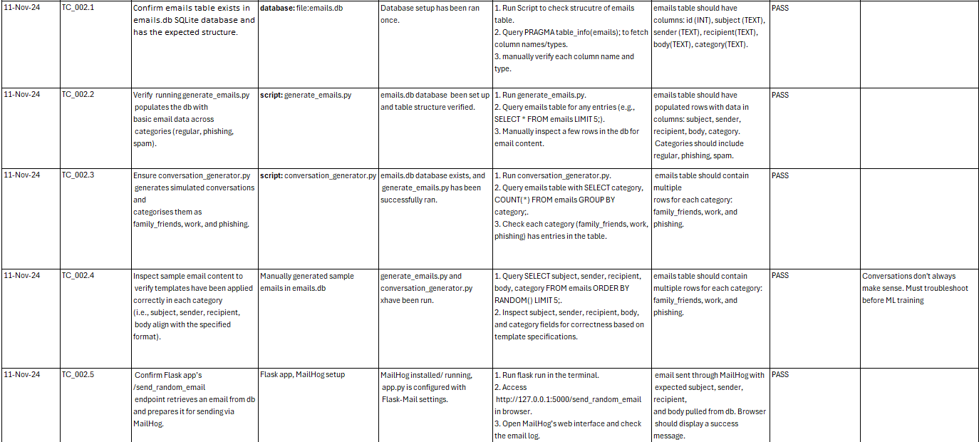
  - Entails: Manual tests for data validation.
    - TC_002.1: Verify database has expected structure. Steps:
      - Run db setup script. Run generate_emails.py.
      - Manually check the table schema using the SQLite client to confirm table structure is as expected.
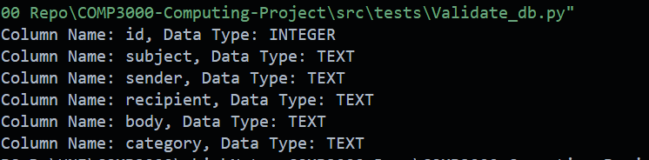
Table schema is correct, pass.
Email insertion works, pass.

      - Run conversation_generator.py to generate the simulated conversations. Labels (family_friends, phishing, work)Verify the rows were added. Expected outcome, counts for each category confirming that each type (work, family, phishing) was generated
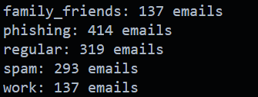
Pass.

      - Inspect email content: Ensure data labelled for ML, features (sender, receiver, body, etc ), manually pick rows randomly to check if the subject, sender, recipient, and body fields were generated in alignment with the intended templates.
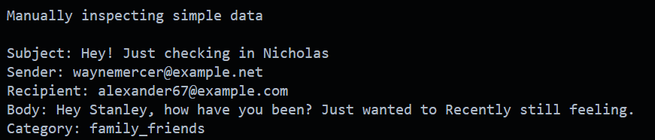
Pass, but generation must be altered since sentences do not make sense. Not good for training the ML model on. This will be fixed in Sprint3.

      - Verify integration with Flask App app.py
        - Send_random_email to confirm emails are being fetched and prepared for sending correctly.
1.
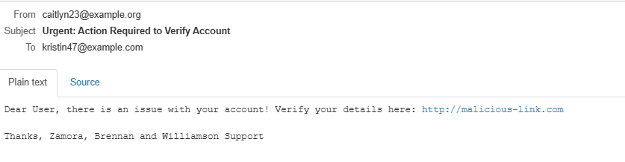
2.
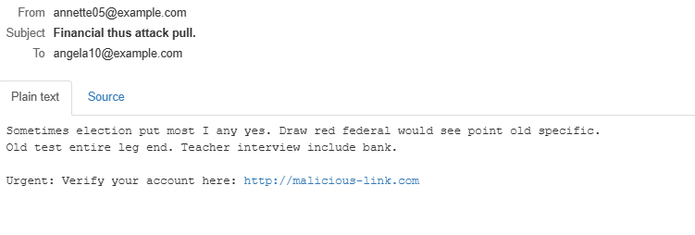
Same issue, sentences do not make sense. Must rectify issue before ML training.

Sprint 3 Testing Plan
In Sprint 2, focus shifts to integrating the model with the email server, expanding to phishing classification, and ensuring the flagging system works as expected.
- Test Case TC_003: Initial model accuracy with simple spam classification.
Unit Tests
- Test Case TC_004: Test classification function to ensure it correctly predicts spam, phishing, or regular. Include tests with known email examples for each category.

- Test Case TC_005: Verify that emails identified as phishing or spam are flagged correctly within the system, ensuring the flagging function is reliable.
Integration Tests
- Test Case TC_006: Set up tests to ensure that the pipeline from email reception (MailHog) through to classification and flagging works without issues. This entails triggering an email event and validating the results in the database.

- Test Case TC_007: Verify that flagged emails are logged with correct details (category, confidence score etc) and that this information can be retrieved easily.
Model Performance Testing
- Test Case TC_008: Assess the expanded model ability to detect phishing emails. Run tests on new model’s performance using a validation dataset with phishing and spam examples.
- Test Case TC_009: Use a confusion matrix to evaluate model performance across classes. Focus on minimising false positives and false negatives for phishing and spam.
Sprint 4 Testing Plan
In sprint 3 testing will be focused on refining the model, testing the monitoring dashboard, and ensuring end-to-end usability in preparation for the MVP.
Unit Tests
- Test Case TC_010: Test UI filtering functions on dashboard to make sure it is accurate and fast filtering by criteria like sender, category, and flagged status.
- Test Case TC_011: Check each email record is correctly displayed in the dashboard, with all relevant data fields (sender, subject, body, and flag status).
Integration Tests
- Test Case TC_012: Write tests to validate that the dashboard displays real-time results as emails are processed. Example, simulate sending emails to check if they appear correctly in the dashboard after classification.
- Test Case TC_013: Test the full workflow from email generation to classification, flagging, and dashboard display, ensuring each stage integrates without flaw.
Model Refinement Testing
- Test Case TC_014: Test the tuned model for better performance on new validation data, recording the final metrics (precision, recall, F1-score).

- Test Case TC_015: Once end-to-end tests are completed, perform a final UAT to simulate real user interaction. UAT would entail testing the flow of sending, receiving, and reviewing emails via the dashboard.
End-to-End Testing
- Test Case TC_016: test the system’s handling of typical email threads. Send a series of test emails with varied content (regular, phishing, spam) to validate that classification, flagging, and UI display are accurate.

- Test Case TC_017: Assess how the system handles multiple emails at once and test response time for dashboard updates. This is important if the MVP needs to be scaled up later.
Tools: pytest and Flask testing client for integration and end-to-end testing, locust or similar for load testing, Scikit-learn for model accuracy tests.

